The Middle Ages

Between Ancient and Modern
Historians mark the fall of Rome as the end of ancient history. The next one thousand years were called the Middle Ages.
The beginning of the Middle Ages is often called the "Dark Ages" because the great civilizations of Greece and Rome had fallen. Life in Europe during the Middle Ages was very hard. Very few people could read or write and nobody expected conditions to improve. They had a strong belief in Christianity, and the hope that life in heaven would be better than life on earth.
Europe began to experience great change by about 1450. Within one hundred years, Columbus had sailed to America, literacy spread, scientists made great discoveries, and artists created pieces of art that we still admire. Historians call the next period of European history the "Renaissance," or the "rebirth." The Renaissance is the beginning of modern history.

Feudalism
Feudalism was the system of government during the Middle Ages. As the Roman Empire collapsed, emperors gave land to nobles in exchange for their loyalty. These lands developed into manors. A manor was the land owned by a noble and everything on it. A typical manor consisted of a castle, small village, and farmland.
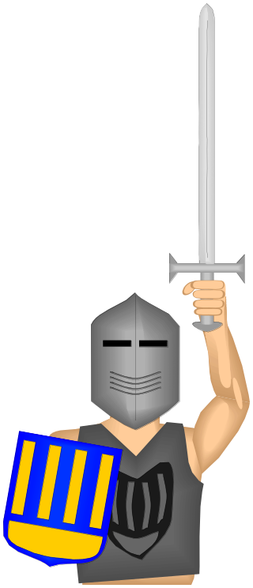
During the Middle Ages, peasants could no longer count on the Roman army to protect them so they turned to the landowners, often called lords, to protect them. Many peasants remained free, but most became serfs. A serf was bound to the land. He could not leave without buying his freedom. The only difference between a serf and a slave was that a serf could not be sold to another manor. Serfs worked three or four days a week for the lord as rent.

Christendom
By the later Middle Ages, the gods of the Romans, Greeks, and Celts had been forgotten, and Christianity became the universal faith of almost everyone in Europe.
Religious life was very important during the Middle Ages because the Church was often the only way to get an education. In the Middle Ages, the Pope ruled the Christian Church.

The Vikings
The Vikings were fierce warriors and skilled sailors. The Viking ships were strong enough to survive the fury of the sea. They attacked without warning and quickly escape. At first they attacked and left with as much as they could carry. Later, they settled down and colonized areas they conquered. By the 10th century, the Vikings controlled parts of Britain, France, and Russia, and raided lands as far away as Egypt.

The Normans
William the Conqueror was a powerful Norman ruler who invaded England in 1066. For the next three hundred years, England was ruled by kings who did not speak English. The Normans imported French-speaking craftsmen, cooks, and scholars.
The Norman Conquest destroyed English rule and created a French military state. The Normans built the Tower of London. It was designed to protect the capital, but it also served as a reminder to the English people of the power of the Normans.
The Norman Conquest was the beginning of centuries of conflicts between England and France. The nations fought the “Hundred Years’ War” between 1336 and 1453. They also competed for new colonies in America.

The Black Death
Almost half of the people of Western Europe died in a great sickness known as the Bubonic Plague. The plague was also called "the Black Death” because the skin of diseased people turned into a dark grey colour. It apparently began in China. When sailors travelled to Asia, rats returned with them to Europe. Fleas living on the blood of infected rats then transferred the disease to the European people. The Europeans were vulnerable to disease because they had very poor sanitary conditions. Also, medicine was primitive and unable to cure the disease. Some Europeans believed the plague was a sign from God. The Bubonic Plague continued to affect cities from time to time for hundreds of years.

English Kings
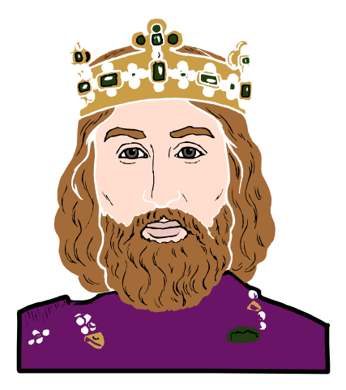
The Middle Ages cover one of the most exciting periods in English History. Starting with the Battle of Hastings and the Norman Conquest in England - when William the Conqueror took the lands from the Saxon and gave them to French nobles. The Kings and Queens of England in the Middle Ages included Richard the Lionhearted, King Henry II (1154-1189) and King Edward III (1327-1377).

Richard the Lionhearted (1189 – 1199)
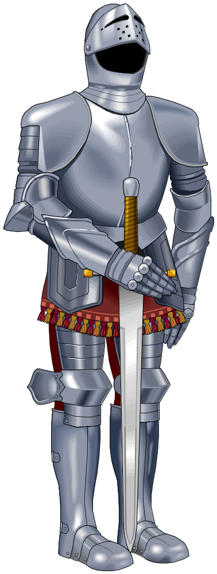
Richard was a fierce and brave king. He spent only 6 months in the Kingdom because he was always fighting abroad. He cared little for England and spent all the kingdom’s money to finance his battles. He died defending a castle.
John Lackland (1199 – 1216)
John is still called “England’s worst king”. He was given his nickname, 'Lackland', because of his lack of inheritance and for his loss of territory to France as well as because of his military ineptitude. He inherited an empty treasury and a war with France. During his reign he increased taxes to collect more money. The Barons were furious and made him sign the Magna Carta in 1215. The Magna Carta was a feudal document that strengthened the barons’ position and reminded the King that his power had limits; that he was under the law.
Richard III (1483 – 1485)
King Richard III was proclaimed king in 1483. He imprisoned and killed the two princes (sons of Edward IV, his brother) to become King. Richard was an unpopular man and king. He was defeated by Henry Tudor at the battle of Bosworth Field. It appeared that Richard was abandoned by many of his men during the battle. These men transferred their loyalty to Henry Tudor.

